Hasan Al-Habbobi 216315428

Sharujan Rajakumar 216376410

Alain Ballen 216341703

Ahmed Hagi 215043896

**USER MANUAL - GROUP 5**

**Purpose:**

The purpose of this document is to explain how the user can install the system as well describe the major use cases. Accompanying screenshots and links to videos are provided to help users become more familiar with how to use the application.

**Table of Contents**

**1.0 = Installation**

**1.1 - Download Exe Type of File**

**1.2 - macOS Installation**

**1.3 - Windows Installation**

**1.4 - Linux Installation**

**1.5 - Instructions to Install Software**

**2.0 = User Manual & Features**

**2.1 - How to Get Started**

**2.2 - Features and How to Use**

**2.3 - Future Features**

**3.0 = Common Usage Scenarios**

**3.1 - Math and Science**

**3.2 - Statistics and Probability**

**3.3 - Business**

**3.4 - Other Comparisons**

**1.0 = Installation**

**1.1 Download vM Release File**

Double click on the Github URL and download the release file (either as a zip or by pulling the release to your computer). In the case of downloading a zip file the user can then install the runnable .jar file (in the vM release) on the following operating systems as outlined for 1.2, 1.3 and 1.4 respectively.

**1.2 - macOS Installation**

1. Unzip the .zip file
2. Drag and drop the icon to your Applications folder
3. Double click the program to start
4. A dialog box will appear. Follow the instructions to install the software*.

**1.3 - Windows Installation**

1. Unzip the .zip file
2. Place the folder into your computer (It will usually be in your Downloads folder).
3. Double click the program to start
4. A dialog box will appear. Follow the instructions to install the software*.

**1.4 - Linux Installation**

1. Right-click on the .zip file
2. Select “Open With Archive Manager”
3. Within Archive Manager, select “Extract” and choose a location within your computer
4. Double click the program to start
5. A dialog box will appear. Follow the instructions to install the software*.

**1.5 - Instructions to Install the Software**

Double click on .jar file. Program will immediately run

IMPORTANT NOTE:

The application might not work without Java 8 so it is advised to make sure you have it before downloading and running the application.

**2.0 = User Manual & Features**

**2.1** - **How to Get Started**

NOTE:

Each of the following steps are accompanied by videos and screenshots to demonstrate the step in action.Greater details about each of these steps/features are provided in section 2.2

**Step 1**

Step 1.1

Start by clicking the application logo which will open the application as seen in the image below.

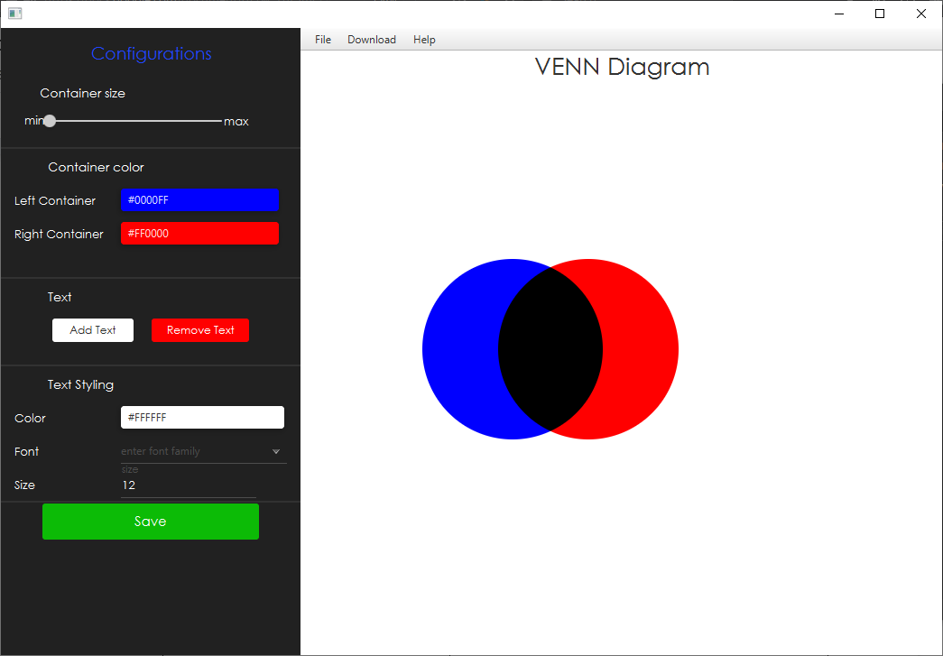

Step 1.2

Click file followed by the “new project” button

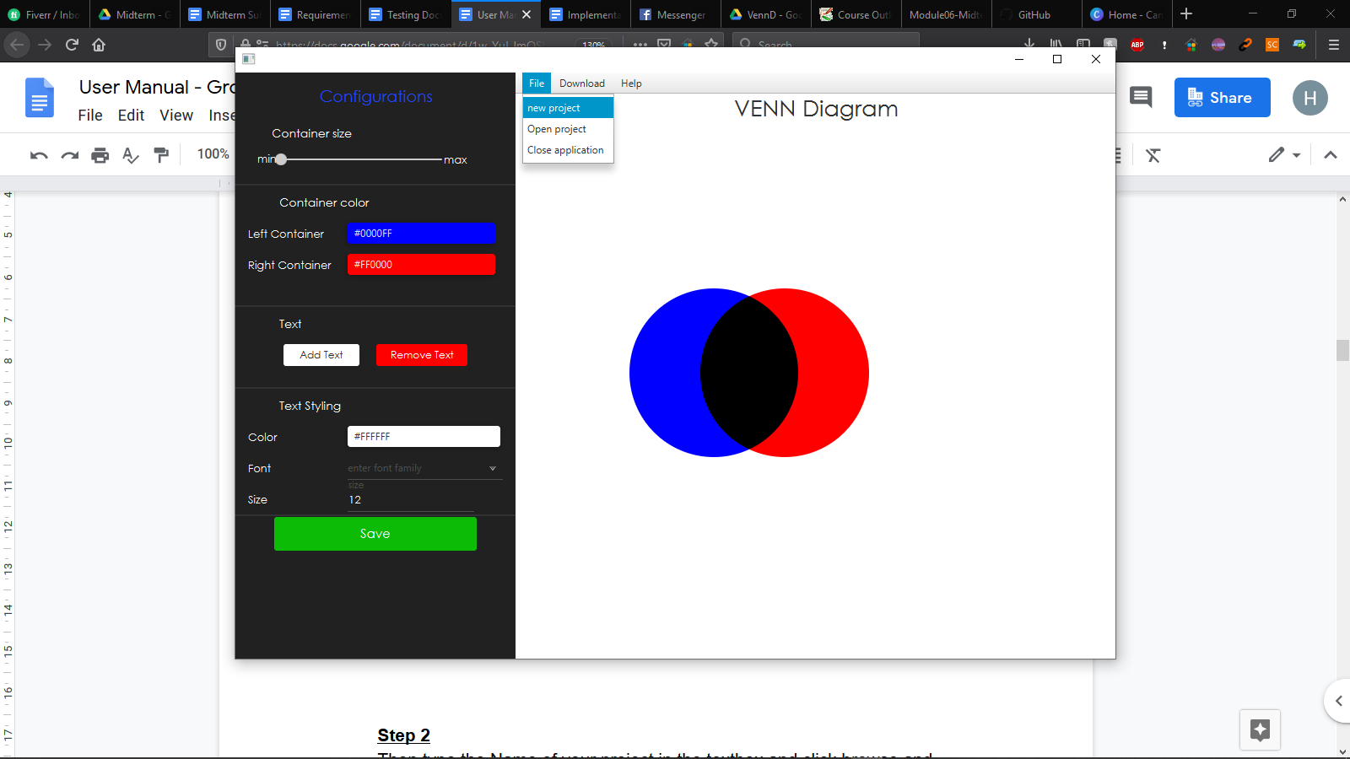

**Step 2**

Then type the Name of your project in the textbox and click browse and search for a location you want to save your in your computer/drive

**Step 3**

You are now ready to build your first Venn Diagram

*Step 3.1*

Start by selecting the preferred size of the circles/containers/diagrams (as shown in this video:

<https://drive.google.com/file/d/1IBjCb3Nzc3b1-e_zmVfRMqV102HXn_Pm/view?usp=sharing>).

*Step 3.2*

Then choose the colors for the diagram by clicking “the drop-down color picker menu designated (as demonstrated in this video: <https://drive.google.com/file/d/1qefClwicIAcjaIXLEADs2VMZXlFQOnBl/view?usp=sharing>).

*Step 3.3*

The user is then able to at any time add as many text elements as they want and drag them to where they would like to position them (e.g. in the left circle, right circle or the intersection) (as shown in this video: <https://drive.google.com/file/d/1LRT2QWQweWqm0JNlXb0vXcgzN7HTjayM/view?usp=sharing>)

*Step 3.4*

The user can double click on a text element and change the text of the element (as shown in this video:

<https://drive.google.com/file/d/1yyb8b8N9w85sHq7oAI46efnPC5oyEdTk/view?usp=sharing>).

*Step 3.5*

The user can also change any individual text element’s font, size and color independent of each other (as shown in this video: <https://drive.google.com/file/d/12rYUUFfg6JSze1_jlR8RHauPpRqrXY9x/view?usp=sharing>).

*Step 3.6*

The user can also delete a text by clicking the “Remove Text” button. Or they can delete all text by clicking the “Clear All” button



NOTE:

These features/(steps 3.1 - 3.6) can be used at any time while working on your project.

All The features mentioned in section 2.1 are discussed in greater detail in section 2.2

**Step 4**

Throughout working on your diagram or When you are finished click “Save” or click Save As to change the name of the project or the location of where you save your project to save the most recent version your project

**Step 5**

You can reopen this project later or open another project by clicking “Open” and browse to where you saved your project and double left click on it or single left click on it and select open to open that project.

**Step 6**

You can download your diagram as a PNG by clicking the “Download” button followed by selecting either “Download as image” or “Download as pdf” to download the diagram as a PDF file.

**2.2 - Features and How to Use**

The following are features which the prototype has already implemented as well as descriptions of what they do and how the user can use them.

|  |  |
| --- | --- |
| **Features** | **Description of how it functions** |
| **Change Container Size** | The user can use the Container size slider to change the size of the circles to their desire by left clicking on the circle and moving to either the right or left. Moving the circle slider to the right will increase the size and moving it to the right will decrease the size. Max and Min indicate the limits of the size slider. An image of the slider is shown below    To give an idea of the difference of the different sizes images are shown below:  Min      Middle      Max      NOTE: that the size can be changed at any time |
| **Change Container Colour** | A selection of colours will be added for the user to choose from in the form of a drop-down color picker menu.    Upon clicking the button a drop menu appears allowing the user to choose one of many colors    Upon selecting a color the container/circle will change to the corresponding colour.  Example shown below:  Left Container: Green  Right Container: Red    NOTE: the colors can be changed at any time |
| **Add Text Elements** | User is able to add text elements which can be used as:   * Title for the project * Titles for the containers/circles * Headings for elements * Descriptions for elements   To add text simply click the “Add Text” button    Which will create a text element with the default text “enter text here”    NOTE:  The user is able to add as many text elements as they wish |
| **Move Text Elements** | The user can to left-click and hold on a text and move their mouse to position the text element where they want. They can do this process with any text elements to move text elements where they like as shown in the below screenshot where the text “Bob is dragged from the left container to the right container |
| **Edit Text Elements\*** | Text can be edited with respect to the following attributes:   * Text value * Color * Font * Size   Lets take the following text “BOB” as example    ***To edit the Word of the Text***  The user can first double left mouse click on “BOB” which will prompt a textbox for the user to change the word of the text. In this example we will change “BOB” to “BOBBY”      ***To edit Text Color***  The user can single left mouse click the rectangular box button next to the word “color” as seen below.    This will open a color menu picker where the user can click on any one of the colors shown below. For this example we will choose the color yellow  The user can then single left mouse click on the texts they want to change to the color yellow (e.g. on “BOBBY” to change it from black to yellow)      *NOTE:  A better version of color picker and edit text element in general is being worked on where The user can instead single left mouse click on “BOBBY” and then click the rectangular box button to change the color from the drop down color picker menu.  *More details about this are discussed at the Note section at the end of this table.*  ***To edit Text Font***  The user can click on “enter font family” drop down menu button next to the Font label    Clicking it will bring up the following menu    For this demonstration purpose we will select Comic Sans MS    To edit Text Size  The user can click on the number next to the size label and enter a new number/size |
| **Delete Elements\*** | Clicking the “Remove Text” button in the program as shown below    will delete a text element.  NOTE:  This feature is being tweaked so that Text Elements can be single left mouse clicked on and then deleted by clicking the “Delete” button keyboard or clicking the “Remove Text” button in the program as shown below  *More details about this are discussed at the Note section at the end of this table.* |
| **Download As** | The user can click the “Download” button    Clicking this button will prompt the user to a menu where they can choose between “Download as pdf” or “Download as image”    This allows the user to export /save/download their venn diagram as a PNG or PDF and save it onto their personal computer.  The user can click either the “Download as pdf” or “download as image” button. From there a pop up window will appear allowing them to browse for a location they want to store the file as well as change the name of the file.    Once they have done either of those things they can click the “Save”button to download it in that location they selected under that name they selected.  If the user clicked the “Download as image” button then a png image of the diagram was downloaded to that location.    If the user clicked the “Download as pdf” button then a pdf file of the diagram was downloaded to that location.  NOTE:  “Download as image” has been implemented but “Download as pdf” has not yet been implemented |

*NOTE:*

*\*For “Edit Text Element” and “Delete Text Element” an adjusted version is being worked on where the user can single left mouse click on a text element which will bring that text into focus (will put a box around the text indicating that it has been selected). From there the user can edit that individual text’s properties (color, size, font) or delete that text element.*

*Also Note that we couldn’t implement all of the features we wanted to make; hence section 2.3*

**2.3 - Future Features**

The following are features that are missing which will be added in future versions of the application

|  |  |
| --- | --- |
| **Features (To Be Implemented)** | **Description of how it functions** |
| **Open Project** | The user can click File and then “Open Project” button    This will open the project including the containers and all the text elements that were added as well as all of their properties (color, size, etc) in the same way they were when the project was last saved. For example if the left container was blue when last saved then the opened project container will be blue etc  The program achieves this by reading the text file with its array of properties and recreation each of the text elements based on their defined properties (position, words, color, etc) |
| **Create New Project** | Allows user to begin a new project. User can click File and then“new project”    This will prompt the user to enter the project name as well as the location of where they would like to save their project |
| **Save** | Clicking the “Save” button will save all text elements and circles/containers as well as their properties (e.g. color, size, etc) in an array in a text file which the application will read to keep the users progress*.    This way the user can close the application and reopen it to work on a Venn Diagram they started working on before.  *See “Open Project” for how saved work is opened |
| **Save As** | Clicking the “Save As” button does the same thing as the “Save” button except it also shows a window where the user can change the name of their project and or change the location of where they save their project |
| **Container Shape Selector** | Allow user to change the shape of their container to other shapes instead of just circle |
| **Edit Text Margins** | Allow user to adjust text margins so that text can fit narrower/wider column styles based on the users needs/desires |

**3.0 = Common Usage Scenarios**

There are many different use cases for this Venn Diagram application. This User Manual outlines 3 (Math and Science, Statistics and Probability and Business). Furthermore this User Manual will go into detail with an example Usage Scenario for a general comparison (3.4) using the prototype application.

**3.1 - Math and Science**

Enables students to visualize and organize information to see various relationships among sets, or groups of objects.

Scenario: A science student wants to compare the similarities and differences between two animals to help them visualize which animal they would prefer to present on.

**3.2 - Statistics and Probability**

A visual comparison of probabilities of different events occurring based on the probability of their factors being met, etc

Scenario: An economist wants to compare the statistical consequences of an economy crashing due to a stock market crash vs a war.

**3.3 - Business**

Comparison between different products/services to determine which one of the two is the better option

Scenario: An entrepreneur wants to compare the similarities and differences between using a domestic vs foriegn supplier and weigh the differences to help them make a more informed decision.

**3.4 - Other/General Comparisons**

A visual comparison of two competing ideas

EXAMPLE Scenario:

A highschool student wants to compare the differences and similarities between two universities to see which one they should prioritize getting into.

Let's say that after doing their research they form the following table (note that this table is purposefully simplified for demonstration purposes).

|  |  |  |
| --- | --- | --- |
| Ryerson | YorkU | Similarities |
| * Downtown Toronto location * Well known for its: Film Program | * North York Location * Has software engineering program * Well known for its Schulich Business Program | * Public transit available (TTC, GO) * Both have New Student centres and athletic facilities |

Now let's say that the student wants to represent the above data in the form of a Venn Diagram. They can use our application to do that. Here's how:

**Step 1 | Download and Installation**

*The highschool student can follow steps outlined in 1.0 to install the Venn Diagram Application.*

NOTE:

For the remaining steps more detail regarding their implementation can be found in in 2.2

**Step 2 | Select Size of Container/Circle**

*The highschool student can single left mouse click and hold and slide the container size slider to either the left or right:*

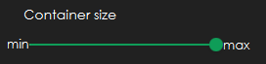

*(e.g. in this case container was slided to the right to max size)*

**Step 3 | Select Colour of each Container/Circle**

*The highschool student can left click on each of the drop down menus and left click to select the colour they would like for each circle/container (left and right). 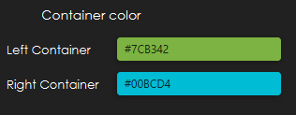*

*The colour can be one of the following options:*

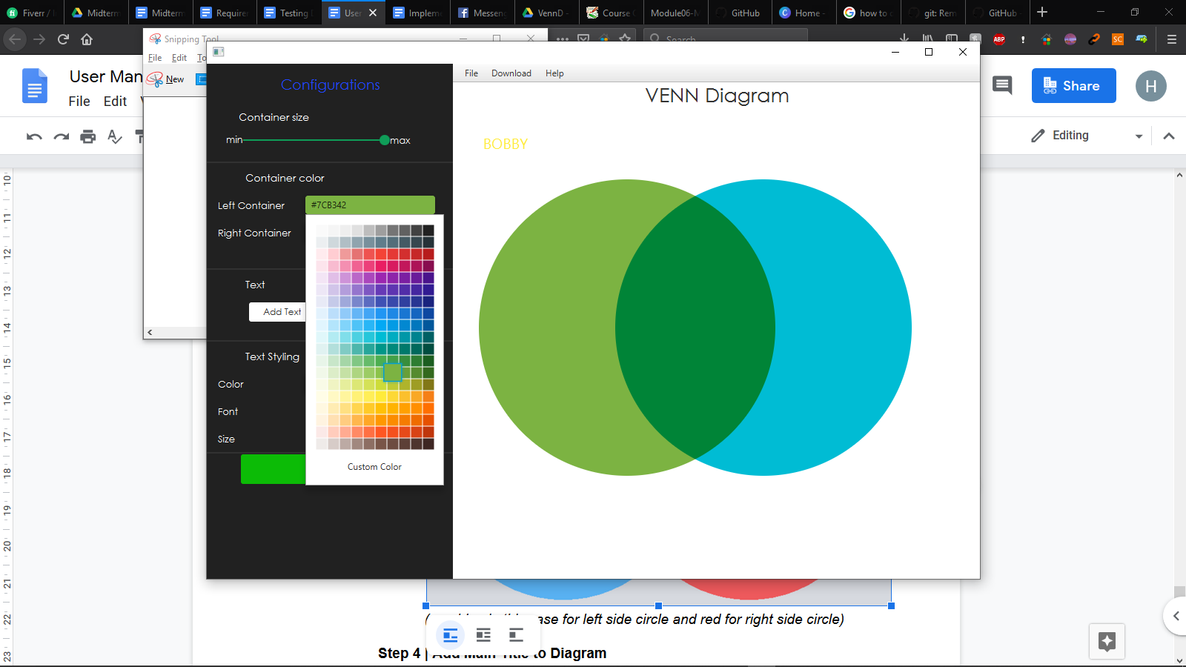

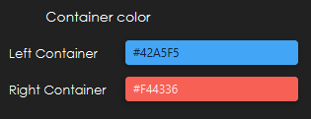

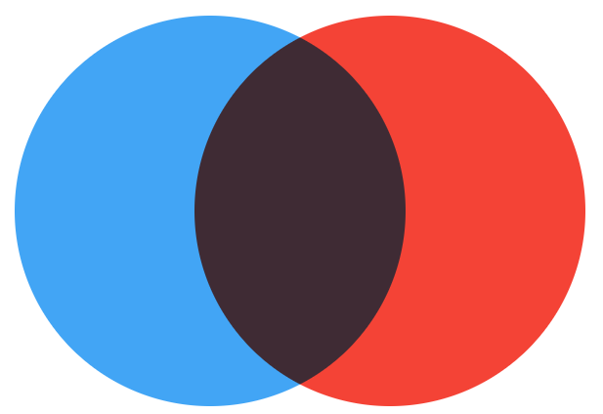

*(e.g. blue in this case for left side circle and red for right side circle)*

**Step 4 | Add Main Title to Diagram**

*The highschool student can add a text field and type: “Ryerson vs YorkU”. They can then change the font, colour and size (e.g. to Arial, Black and 18)*

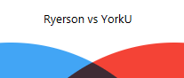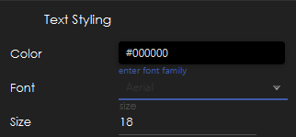

**Step 5 | Add Ryerson TItle to one container and YorkU to another**

*The highschool student can add a text field and type: “Ryerson”. They can then change the font, colour and size (e.g. to Arial, Yellow and 14)*

*They can then do the same except type YorkU instead of Ryerson and use the colour red instead*

**

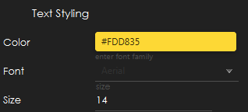

**Step 6 | Add 7 Text Elements to the Diagram**

*The highschool student can add 7 text fields. They can then change/Edit the text of Each of those 7 Text Elements to one of the dot jots outlined in the table above*

**Optional Step | Edit/Delete A Text Field**

*The highschool student can select any one of the text elements and change their property (font, colour, size) or delete the text element entirely.*

*Note: The container sizes can be changed at any time via step 2 and container colours can be changed at any time via step 3*

**Step 7 | Move each text element to a place that makes sense for you**

*The highschool student can move each text element to a position that makes sense for them (an example is the Venn Diagram presented below)*

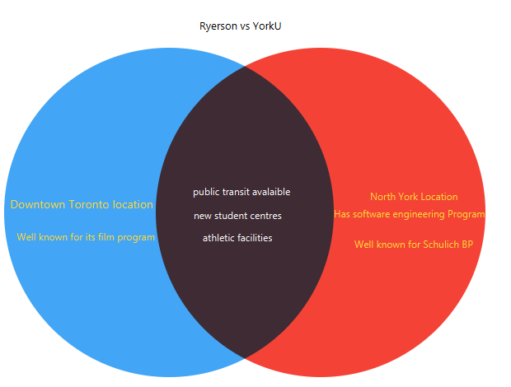

**Optional Step | Save Project and Reopen Later**

*Should the student wish to work on the project later the highschool student can click the Save button to save their project so far. Or they can click the “Save As” button should they wish to not only save the project but save it under a new/different name and or location. Then the student can close the application and come back later to work on it later. Whenever they come back to work on it they can click “Open Project” and click browse and search for where they saved the project. They can then either double left click on it to immediately open it or left click once on it then click the open button for the project to open.*

*Note: This optional step can be repeated as many times as the student wishes; allowing them to continue to work on their project later whenever they want.*

*Note: This feature is still being worked on for the final version as mentioned in Section 2.3*

**Step 8 | Save Project and Download as a PNG image**

*The highschool student can click the “Save” button* 

*followed by clicking the “Download as image” button.*

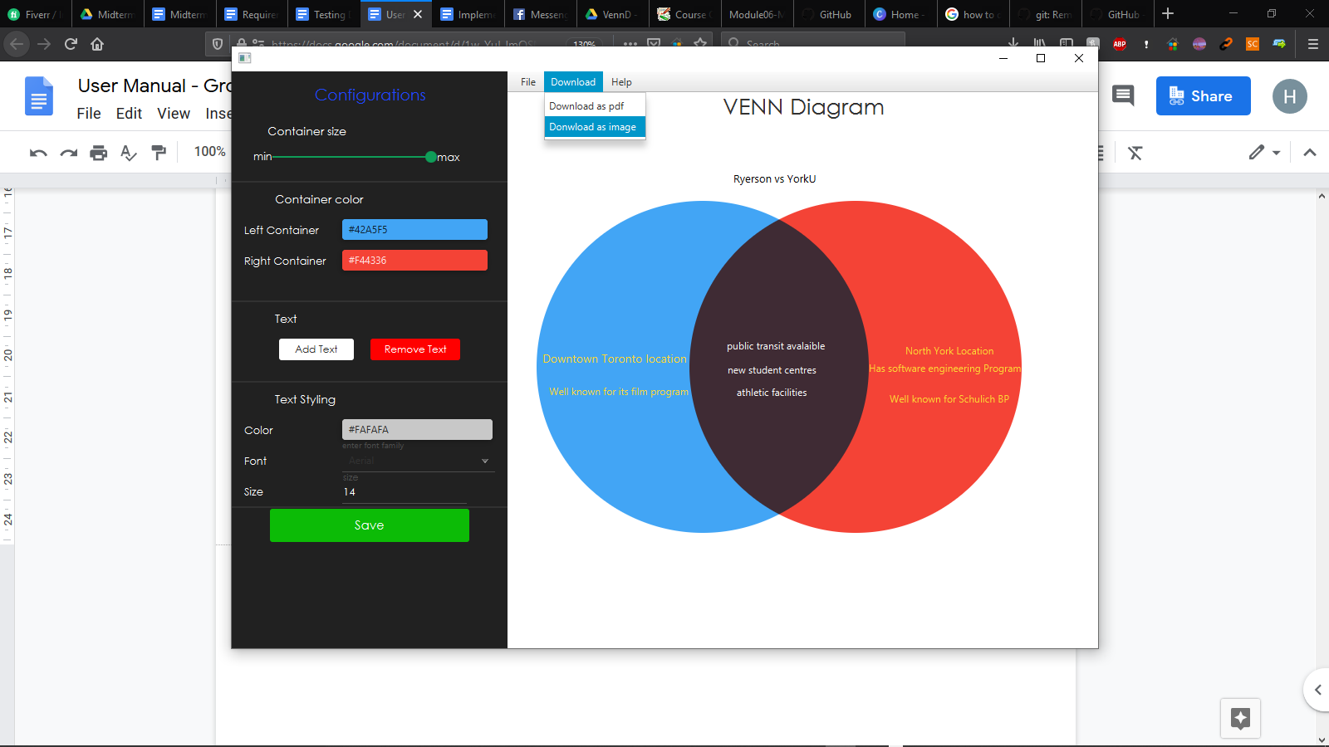

*The student is then prompted with a popup window allowing them to choose where to save the project and which name to save it as (followed by clicking the save button). This will create a PNG image of the diagram and save it as (e.g. in downloads folder saved as “My Diagram” as shown below).*

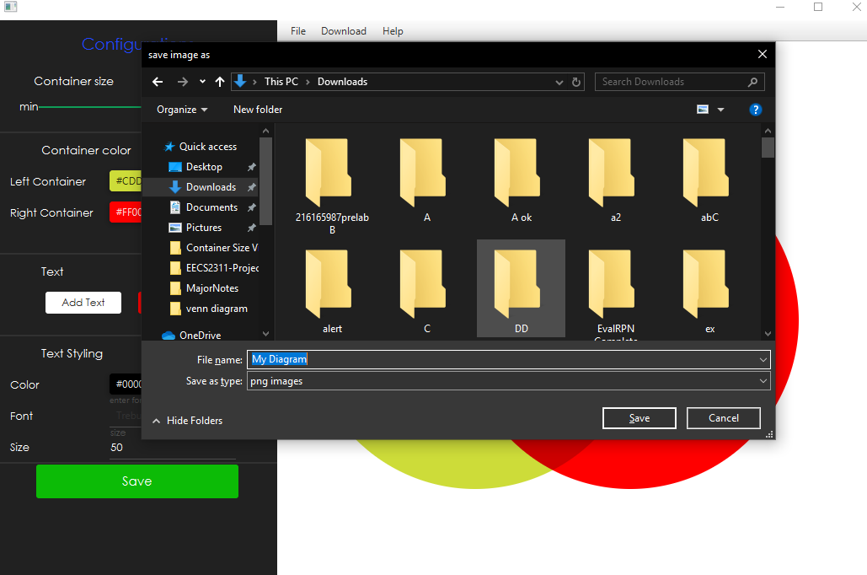

*This allows the student to use or share this image via other social platforms etc (e.g. a presentation about which University is better: York or Ryerson).*